Project Title

Author list

Only include the names of authors. If a team member fails to contribute, then leave their name off the list.

Zhaoyu Zhang z5394117

***This document is a sample for a generic project. The suggested sections, sub-sections and notes are a guide only.***

### Table of Contents

Introduction 3

Executive Summary 3

Problem Statement 3

Conceptual Design 4

Design Concept Generation 4

Design Concept Evaluation 4

Design Solutions 4

Design Considerations 5

Materials 5

Mechanical 5

Electrical 5

Computing 5

Assembly 5

Final Design 6

Design Sketches 6

Design Details 6

Design Innovations 6

Budget 6

Project Planning 7

Timeline 7

Risk Assessment 7

References 8

Appendices 8

Other 8

# Introduction

## Executive Summary (Michael)

This is similar to an abstract in a research paper.

* Keep to the facts, this is not a sales document.
* State the key point, including any conclusions, this is not a mystery novel.
* The client should be able to get the full picture from these paragraphs.

This paper presents the proposed solution for the Robot to the Rescue (R2R) project. It outlines the problem statement, design choices for three areas – manufacturing, computing and electrical, initial design concept and diagrams, which ultimately result in a final proposed solution with detailed diagram and specifications. Furthermore, this paper also lists the budget for this project in detail while presenting all necessary tasks to be completed in a gannet chart. The risk assessment ensures all potential events with negative consequences are considered and prepared for with detailed response actions and contingency plans which minimise any potential disruption to the successful completion of this project.

## Problem Statement

This paragraph sets the context for the whole design. It is often called ‘background’ in other documents.

Inspired by the RoboCup competition, the project aims to design a tele-operated rescue robot that shall be capable of navigating through a complex environment of rough terrains, maze walls, and stairs ranging from 6mm to 36mm whilst avoiding collisions to locate and extract a single survivor represented by a tennis ball. The robot must locate the victim and report back to the operator before transporting it back to the starting location. The Robot will be powered by an Arduino uno microcontroller that allows the operator to remotely control the robot’s actions. Furthermore, the robot must be able to fit inside a cylinder 250mm diameter and 250mm height and must weigh less than 1000gm. The entire build from scratch must cost under $120 and comply with the time constraints.

# Conceptual Design

This section deals with concepts (plural) and their evaluation and selection. The client wants to know that you considered all the options and made the best choice and **why.**

* There will be some overlap with the EDP presentation.
* Keep to the facts and avoid it being a narrative.

“The designs were evaluated using ….” NOT “Then the team discussed each design and …”

* Use tables and charts to communicate complex data.
* Use the tools described in lectures.
* Justify your final design concept with facts not opinion.

## Design Concept Generation (Selina)

The team embarked on a systematic and creative journey of concept generation in an endeavour to design and develop a rescue robot. A combination of concept generation techniques were employed to explore a wide range of ideas including the Method, 6-3-5 Brainstorming Sessions, Mind Mapping, Morph Chart, and Storyboarding.

**Gallery Method**

One of the adopted approaches in the concept generation process was the utilization of the Gallery Method. This method involved allocating a specified period for each team member to independently engage in brainstorming and sketching their initial design ideas. The primary objective of this approach was to encourage individual idea generation and provide a platform for the emergence of unique concepts.

Implementation of the Gallery Method aimed to stimulate the creative thinking of each team member and generate a diverse range of ideas. The next step involved sharing and gathering feedback on the design sketches. This feedback exchange was a critical component of the process, as it allowed for a more comprehensive evaluation of the individual concepts and provided insights into their strengths and weaknesses.

The feedback obtained from the Gallery Method played a pivotal role in guiding the subsequent stages the concept generation process. It served as a valuable source of information that directed the team towards the selection and refinement of ideas that exhibited the most promise and potential. This method, therefore, facilitated a structured approach to concept development and contributed significantly to the overall creativity and innovation in the project.

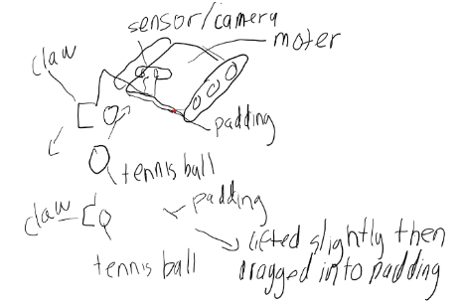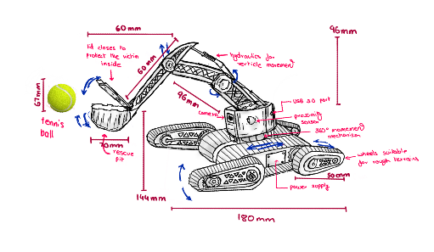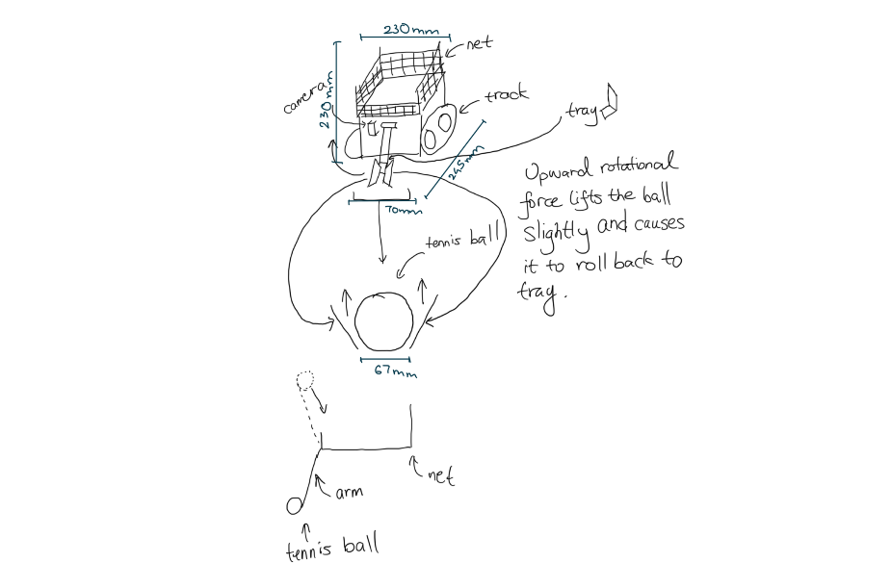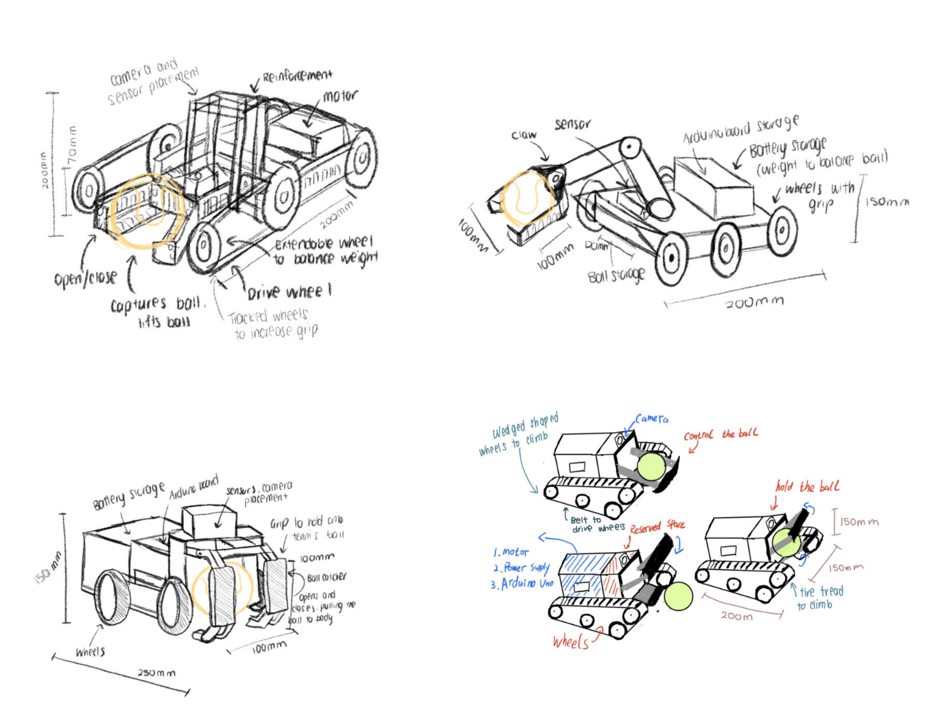

**Brainstorming**

The team transitioned to a more collaborative approach by embracing brainstorming in an open, non-critical environment. This shift in methodology was pivotal in fostering creativity and promoting collaboration among team members, which are essential elements in generating innovative concepts.

In the free-flowing and non-critical brainstorming environment, team members were encouraged to express their ideas and thoughts without fear of judgment. This atmosphere allowed for a diverse range of ideas to surface, benefiting from the collective intelligence of the team. It provided the space for unconventional and novel ideas to emerge, which is often vital in the development of innovative solutions.

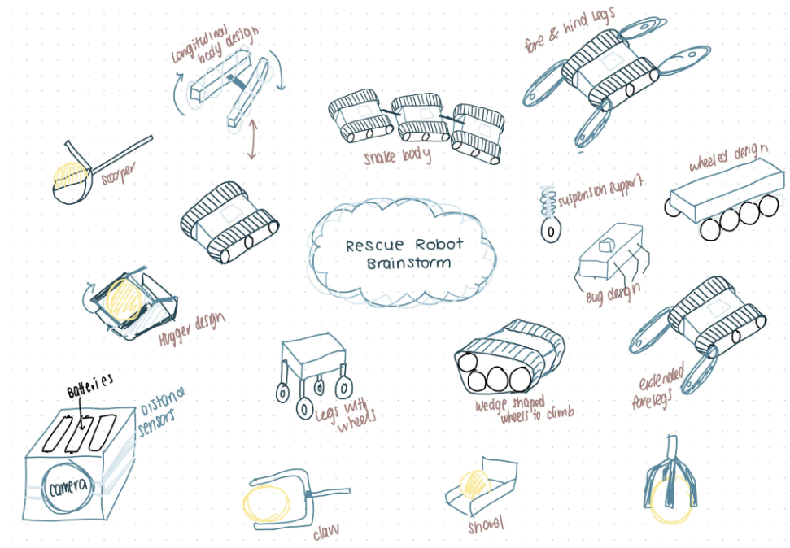

**Figure ________: Rescue robot brainstorm sketched and produced by Selina Li**

**Mind mapping**

The method of mind mapping followed which involved creating a visual representation of the concepts generated and their interconnected relationships. By visually mapping out these relationships, the team aimed to achieve a comprehensive and holistic understanding of the robot's design. The process identified the core components and how they related to one another within the larger context of the rescue robot project. This visual representation served as a valuable tool for structuring and organizing the ideas generated during brainstorming, providing a clear overview of the design landscape. It facilitated better communication among team members in the design process

**Story boarding**

Storyboarding played a critical and central role in the concept generation process. It entailed the creation of a visual narrative that illustrated the operation of the rescue robot. This approach facilitated a comprehensive exploration of how the robot would interact with its environment and effectively address the challenges it might encounter during rescue missions.

By visually depicting the robot's operation in various rescue scenarios, the storyboard allowed the team to brainstorm and consider potential solutions and strategies. This method was invaluable in breaking down the robot's complex functionality into its fundamental attributes.

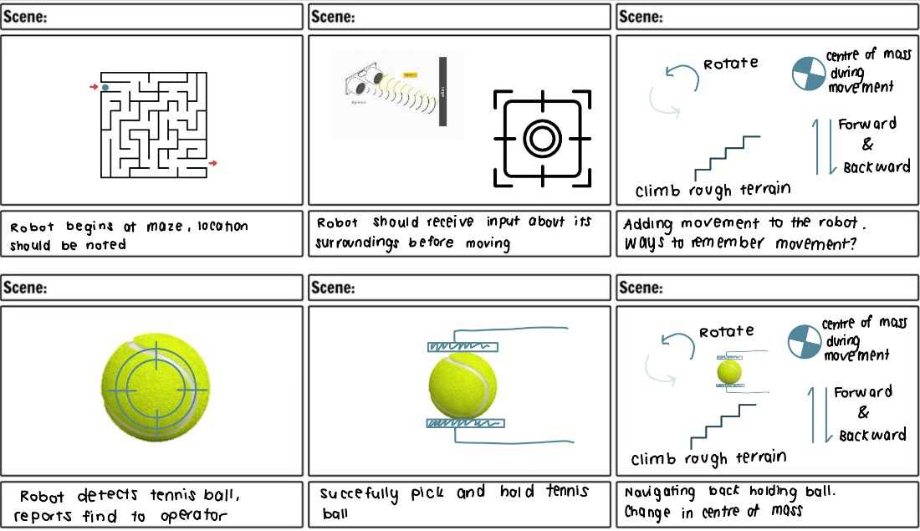

**Figure ________: Rescue robot story board sketched and produced by Selina Li**

**Morph chart matrix**

The use of the morph chart matrix to generated ideas served as a structured framework for categorizing and organizing the identified attributes and features of the robot. By doing so, we aimed to generate a more comprehensive set of fundamental components that were directly relevant to the robot's functionality.

The morph chart matrix served as a foundation for a systematic exploration of these attributes. It enabled the team to experiment with different combinations, seeking to uncover unexpected and innovative solutions. This method encouraged the team to think beyond conventional design boundaries, allowing for the emergence of fresh and unique ideas that had the potential to enhance the robot's capabilities and effectiveness in rescue missions.

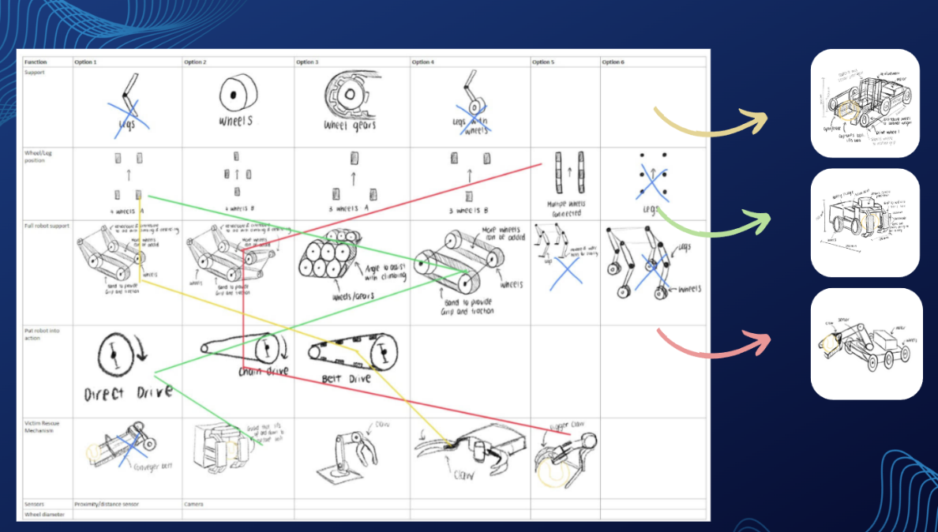

**Figure ________: Morph chart matrix and generated designs sketched and produced by Selina Li**

## Design Concept Evaluation (Selina)

**Numerical Evaluation Matrices**

Numerical evaluation matrices in engineering design concept evaluation are tools or frameworks used to quantitatively assess and compare different design concepts or alternatives. This method of design concept evaluation was utilised to provide a structured and systematic approach for the team to make informed decisions by numerically assigning scores to various criteria and attributes including objectives and constraints associated with each design concept. This enabled the team to observe if the design attribute is Pareto optimal.

A detailed scoring system was established to provide a more nuanced assessment of the rescue robot's design concept in each criterion, allowing for a finer-grained evaluation and clearer differentiation between concepts. It facilitates a more detailed and accurate analysis of each design alternative's strengths and weaknesses.

**Table ________: Numerical evaluation matrix scoring system produced by Selina Li**

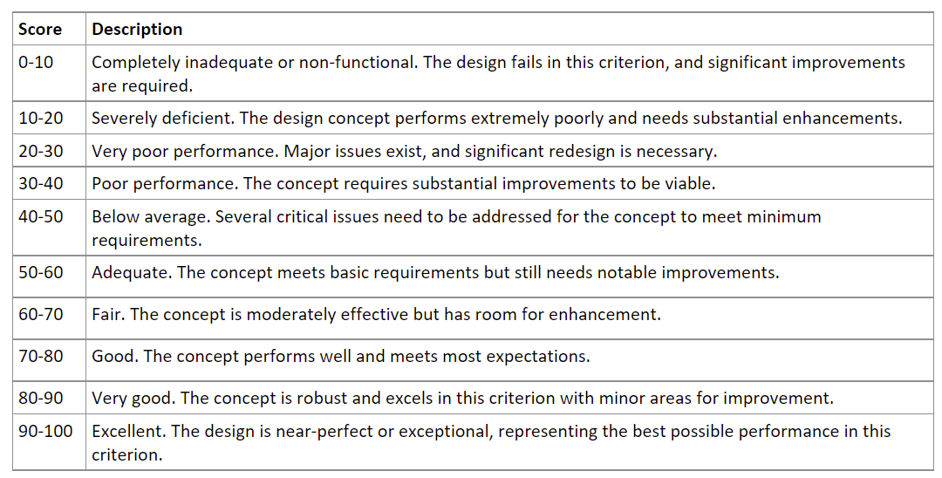

**Table ________: Numerical evaluation matrix scoring for rescue robot support produced by Selina Li**

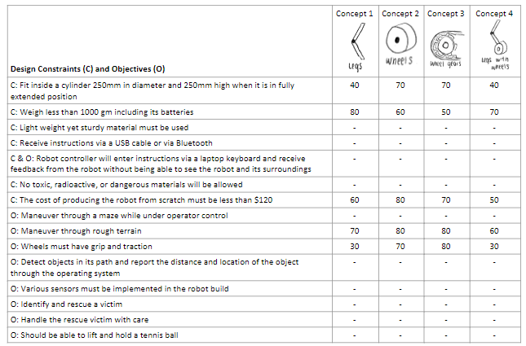

**Table ________: Numerical evaluation matrix scoring for rescue robot wheel positions produced by Selina Li**

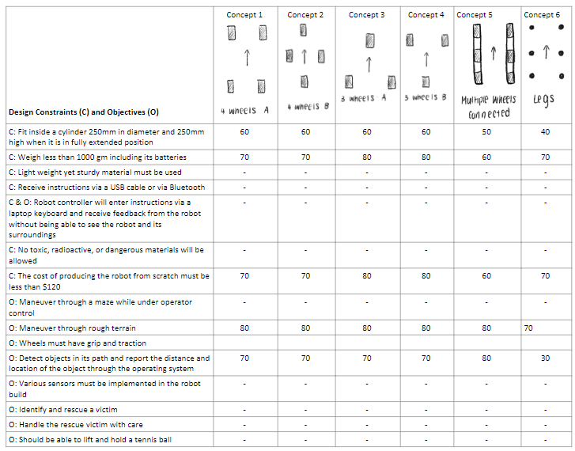

**Table ________: Numerical evaluation matrix scoring for rescue robot wheel support produced by Selina Li**

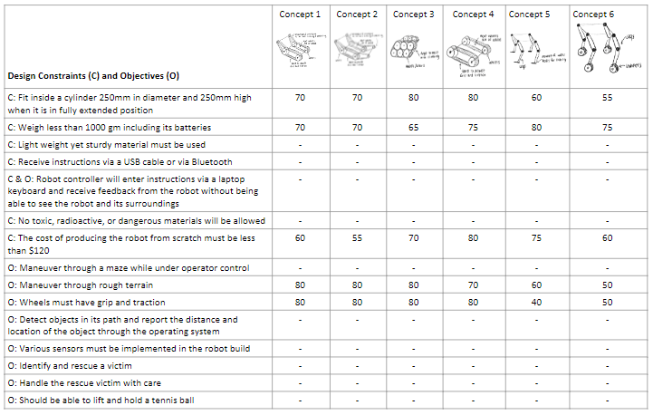

**Table ________: Numerical evaluation matrix scoring for rescue robot ball rescue mechanism produced by Selina Li**

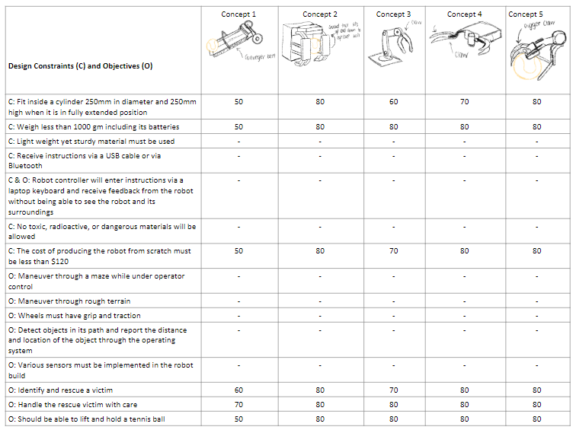

**Weighted percent distribution of design parameters**  
A weighted percent distribution of design parameters conveyed the relative importance or significance of various design criteria or parameters. This distribution helps stakeholders, including project teams, clients, and decision-makers, understand the priorities and focus of the proposed design. The percentage allocation for the distribution of design parameters indicate the proportion of emphasis placed on each parameter with the overall design before the scores were assigned to each parameter then summed to determine the overall performance of the design.

**Table ___________**

**Table _________**

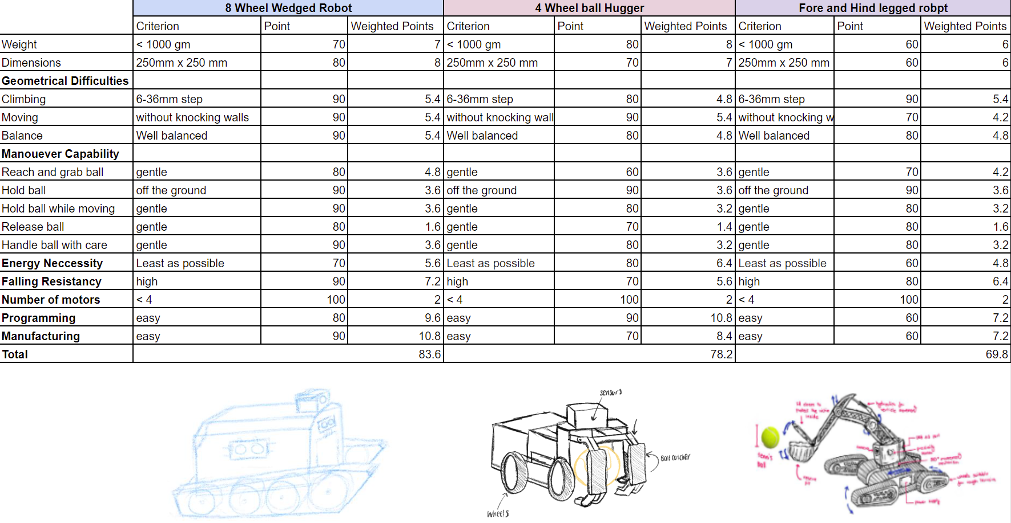

**PMI Evaluation**

PMI (Plus-Minus-Interesting) was a qualitative design evaluation method used to assess and prioritize design concepts or ideas used by the team. The evaluation method involve categorizing aspects of a design as positive (Plus), negative (Minus), or interesting (Interesting). This enabled the team to systematically evaluate and compare different concepts, identify strengths and weaknesses, and uncover potential opportunities for improvement. By providing a provides a structured and systematic approach for design concepts to be assessed from multiple perspectives, critical thinking, idea exploration, and problem-solving are encouraged, ultimately leading to more informed design decisions.

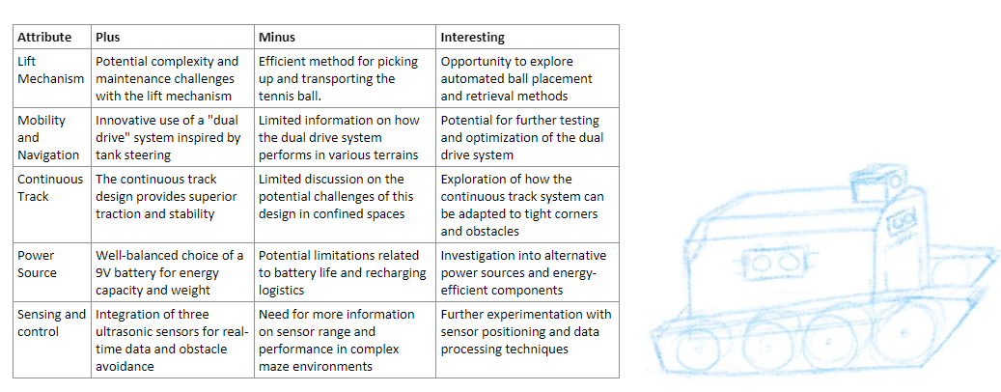

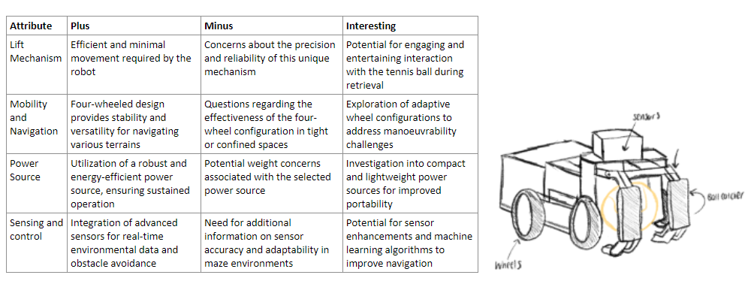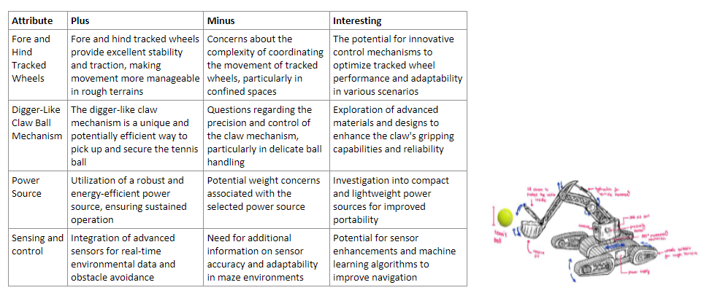

## Design Solutions

The team has conducted a comprehensive analysis and evaluation across multiple facets, including rescue robot support, rescue robot wheel positions, rescue robot wheel support, and rescue robot ball rescue mechanism. After weighted percent distribution of design parameters, the following design solution is proposed.

* Rescue Robot Support: Following a holistic assessment of all design concepts, the wheel gear concept scored the highest, especially in overcoming obstacles. Therefore, this concept will serve as the foundational design.
* Rescue Robot Wheel Positions: Despite not achieving the highest rating, the multiple wheels connected concept exhibits the best alignment with the overall design. As a result, we have opted for this concept for wheel placement.
* Rescue Robot Wheel Support: Concept 4 demonstrates significant advantages in terms of weight, size, and functionality. Consequently, this concept will be adopted for wheel support in our design.
* Rescue Robot Ball Rescue Mechanism: Concepts 2 and 4 received nearly identical high scores for the ball rescue mechanism. Thus, we have decided to amalgamate both concepts to achieve a more comprehensive design solution.

Final Solution: Based on the weighted percent distribution of design parameters, our solution is presented as follows:

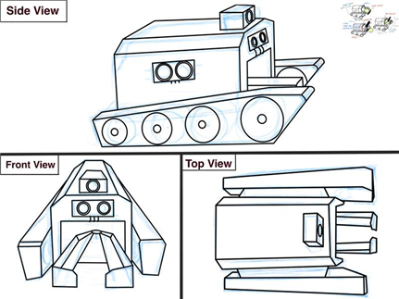

Through a comprehensive evaluation and analysis of multiple design concepts, a design solution that considers various factors has been successfully proposed. It is believed that this solution will provide the best technical support and implementation for [rescue robot support] to address diverse emergency rescue scenarios.

# Design Considerations

This section provides details for design choices when going from Concept to Prototype. For example, the team may decide on a particular wheel speed, but may have to compromise based on the availability of motors and gearboxes.

* Make it real by highlighting the practical choices that need to be made.
* Use technical information from suppliers.
* Use technical information from Tech Streams.
* Present the facts when making a choice.
* The sub-sections below are only a guide.

## Materials

Selecting the appropriate materials for the construction of the rescue robot is a critical step in transforming the design concept into a functional prototype. The choice of materials will significantly impact the robot's performance, weight, durability, and cost. The team made key design considerations and practical choices during the material selection process to ensure the performance and efficiency of the robot is maximised.

* **Chassis Material**

The team decided to use lightweight and sturdy ABS (Acrylonitrile Butadiene Styrene) plastic as the chassis serves as the structural backbone of the rescue robot and ABS provides reasonable strength and impact resistance while remaining budget-friendly.

* **Wheel Material**

Wheels are vital components that influence traction, stability, and durability, especially in rough terrains.

Hence, the team selected rubber wheels as they offer a balanced grip and reasonable durability, ensuring cost-effectiveness while serving the robot's mobility needs.

* **Gripper Material**

The claw mechanism is central to the robot's ball-handling capabilities. The decided to use ABS plastic to 3d print the gripper. ABS provides strength, impact resistance, and precision, ensuring that the claw mechanism effectively grips and transports the tennis ball while staying within the budget.

* **Sensor Material**

Sensor housing materials must protect electronic components and sensors from environmental factors and impacts. To remain budget-friendly, the team selected PVC (Polyvinyl Chloride) for housing. PVC offers basic protection against external elements and mechanical impacts while aligning with the stringent budget requirements.

* **Robot body material**

The body of the rescue robot was one of the most pivotal material selection decisions. The material choice significantly influences the robot's structural integrity, weight, and cost-effectiveness. With a strict budget constraint of $120 in mind, the team have thoughtfully considered two material options: plywood and acrylic, suitable for laser cutting.

**Plywood:**  
Plywood is a versatile and cost-effective material with structural strength and rigidity. It is a composite material made from layers of wood veneers, and it provides excellent durability. Using plywood for the body of the rescue robot is a cost-effective option.

**Acrylic:**  
Acrylic is a lightweight thermoplastic known for its versatility. It is widely used in laser cutting applications to create precise and custom shapes. Opting for acrylic for laser cutting offers the advantage of precision. The laser-cutting process allows for intricate designs and custom shapes, which can be advantageous for creating specific mounting points and openings on the robot's body.

## Mechanical

* **Motor Horsepower**

The constraints on the weight of the robot is 1kg and the weight of a tennis ball is 60g, as such the motor for the robot must generate at least (assuming an acceleration of 0.05 m/s^2). Therefore, the plastic DC motor is selected, as it can generate a maximum torque of 800g/cm (Plastic Geared DC Motor n.d.) which is significantly larger than 54.044 g/cm.

* **Front Arm**

The front arm must generate sufficient torque to lift itself and a 60g tennis ball. Since the arm is constructed with plywood or acrylic (details explained in the previous section), the weight of the tennis ball greatly outweighs the arm. Because the maximum weight of the robot (1kg) is significantly heavier than the tennis ball, it is sufficient to assume that the same plastic DC motor can generate enough torque to rotate the front arm while carrying a tennis ball.

* **Propulsion method**

Only The rear wheels will be connected to the DC motor while all other wheels will remain unpowered. This decision is reached upon careful examination of the benefits and costs of RWD (rear wheel drive) vs FWD (front wheel drive) vehicles. According to Muro (1997), “maximum terrain slope angle up” is “0.031π rad for the RWD vehicle, and about 0.017π rad for the FWD vehicle”. He further accentuates that the “maximum effective tractive effort” of “rear wheel drive vehicle (RWD) … was greater than that of the front wheel drive vehicle (FWD)”. Furthermore, FWD only outperforms RWD in terms of effective braking effort (Muro 1997) – this is not applicable in this project as the robot will be travelling at a low speed (<5km/h).

* **Steering Mechanism**

A differential steering mechanism is selected for this robot. Differential steering means the robot will steer by torque vectoring, which applies “applying different longitudinal forces on the wheels of the same axle”, the resulting yaw moment controls the direction of the robot (Vignati et al.). This is the most practical steering mechanism for the caterpillar track design as it utilizes less moving component than pivot steering mechanisms while allowing for greater control and maneuverability with a small turning radius.

## Electrical

Motors, batteries, and sensors are just a few of the electrical components that must be included in the robot's design. Each of these uses a different voltage, thus it is important to take everything into account. Using high-quality items is necessary because electrical parts are arguably the most significant ones for the success of the vehicle. However, electrical parts are much more expensive than other design elements, therefore this must also be taken into account.

* **Motor**

We have chosen to use a Plastic DC Motor from Create UNSW for the motor because it meets all of our design requirements and is easy to buy. Small robots can operate more easily with DC motors because they are much more affordable and user-friendly. This motor operates between 3 and 12 volts and has a variable speed, allowing our design to move quickly enough and have enough power to get up uneven surfaces, in this case getting upstairs. As was previously mentioned, higher voltage might be used to boost the motors' output, but testing is necessary to determine whether this would be safe or not.

* **Battery**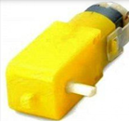

The battery we intend to use is a 9V alkaline batteries because compared with zinc-carbon batteries, alkaline batteries have a higher energy density and longer shelf-life with the same voltage. This is because alkaline derives energy from the reaction between zinc metal and manganese dioxide. Compared with zinc-carbon batteries, alkaline batteries have a higher energy density and longer shelf-life with the same voltage, therefore it is the superior and better battery to use for the robot.

* **Circuit**

Electrical items such as jumper wires and breadboards, also bought from create UNSW will be used to create the required circuits in the robot. This is essential as these items is what transfers voltage and amplitude throughout the whole robot.

* **Sensor**

Ultrasonic sensors are what we plan to use; they are required for the robot to be oriented as well as for it to be able to find and recognize a victim (tennis ball) when it is present. In comparison to other stores, these sensors can also be purchased from Create UNSW for a reasonable price, and it is more convenient. The sensor voltage we intend to use is 5V as this is the operating voltage and most sensors similar to our chosen sensor operates at this voltage as well.

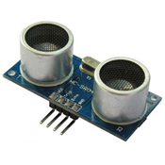

Ultrasonic sensor (create UNSW)

## Computing

* **Camera**

Previously, based on incorrect understanding of the project. Each conceptual design in the team will use a camera. And this plan is a costly and unnecessary choice. It is known in Technical Stream that ultrasonic sensors can completely replace cameras in detecting distance. So, team chose to stop using cameras and instead use sensors.

* **Ultrasonic sensors**

Ultrasonic sensors are necessary in the prototype because there is a requirement to cross the maze and not touch the wall in the problem statement. The main purpose of ultrasonic sensors is to detect the distance from walls in three directions. The computing members in the group need to design an ultrasonic sensor and Arduino uno circuit connection, as well as a program to detect obstacles in three directions of the robot, and finally display them in the serial monitor in digital or image form. This feature also has great application value. When robots perform remote rescue, they may encounter a loss of vision. Ultrasound can detect the surrounding environment without light.

**Technical Implementation**

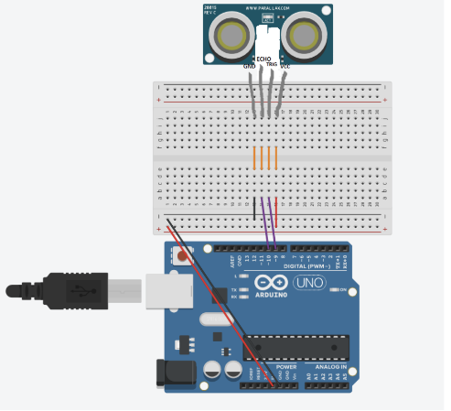

Figure 1 sensors connect on UNO by Zhaoyu

The ultrasonic sensor requires two PWM pins for connection. Next, three identical sensors need to be added.

* **Wheels**

Tank type tracks are used as a means of movement in both conceptual and prototype designs. In the group discussion, it was concluded that using tracks in the prototype design can better cross obstacles and make steering easier. What needs to be considered in the calculation is how to use programming to move the wheels on both sides and complete the steering after the circuit is connected.

**Wheel steering method**

To achieve a turn in a two wheeled vehicle, it is usually necessary to control the speed of the left and right wheels to cause the vehicle to change direction. Here are some programming methods for turning a two wheeled vehicle:

**Differential drive**: By controlling the speed difference between the left and right wheels, the vehicle can turn. When the left wheel rotates at a speed different from the right wheel, the vehicle will rotate around the centre point. The unanimous decision of the team is to use differential drive as the turning method for the robot. This method allows for the simplest operation and allows for a larger turning angle using relatively small space. For example, when a robot needs to turn left, it can make a turn by increasing the speed of the left motor from 255 to -255, while the speed of the swimming motor remains at 255 to form a speed difference。

.

**The specific implementation is as follows**:

Connect two motors to the PWM pins on the uno board and then a motor driver is required to connect the motor. A motor driver can connect two motors.

Next, we will use input operations to control the motion of the motor.

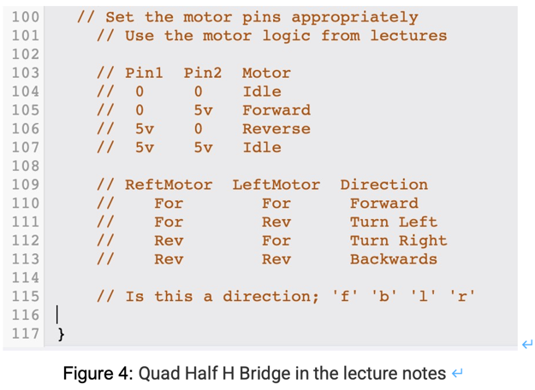

To verify the correctness and authenticity of this code, create a new circuit in Tinkercad to simulate the code. The results are as follows:

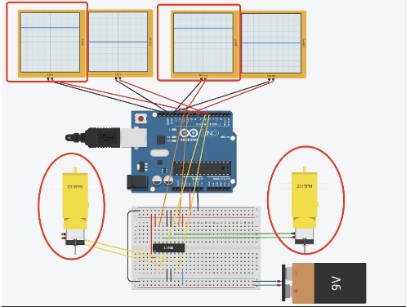

* **Speed control**

The control of speed can change the pulse period and voltage by changing the number of PWM cycles. Speed control is necessary to avoid damage from collisions with walls at specific points. And it can be operated more precisely during rescue.

## Assembly

The focus of this section is on the design of the robot's power system, communication system reliability, obstacle avoidance and safety system, operation interface and human-machine interaction, as well as repair and maintenance friendliness. These analysis points are crucial for ensuring the efficient operation of the prototype in complex rescue missions.

* Reliability of communication system:

The communication system of robots is the core of remote operation and data transmission. The communication system must have sufficient coverage and signal strength to reliably transmit control commands and sensor data in complex environments.

* Obstacle avoidance and safety systems

Our design must be able to avoid collisions and identify potential hazards. This analysis focuses on the types of sensors used to ensure that the robot has appropriate obstacle detection and avoidance capabilities.

* Operation interface and human-machine interaction

The user interface of the robot must be easy to operate and understand. This analyzes different user interface options. Operators need to ensure real-time monitoring of the robot's status and sensor data.

* Maintenance friendliness

Maintenance is a key factor in the design. Team needs to analyze the repair and maintenance needs of robots to ensure that their components are easy to disassemble and replace, so that they can be operated quickly when repairs are needed.

These analysis points are key factors to ensure that robots have sufficient power, communication, safety, operability, and maintainability during rescue missions. They are crucial for the success of the project, ensuring that robots can efficiently respond to emergency situations.

# Final Design

In the culmination of our design proposal for the rescue robot tasked with retrieving a tennis ball in a complex maze consisting of rough terrains, we present a final design that leverages a lifting mechanism, multiple sensors, as well as sufficient manoeuvrability. The design concept has evolved through rigorous brainstorming, concept generation techniques such as mind mapping and morph chart matrix, and the input from team members as well as educators and mentors.

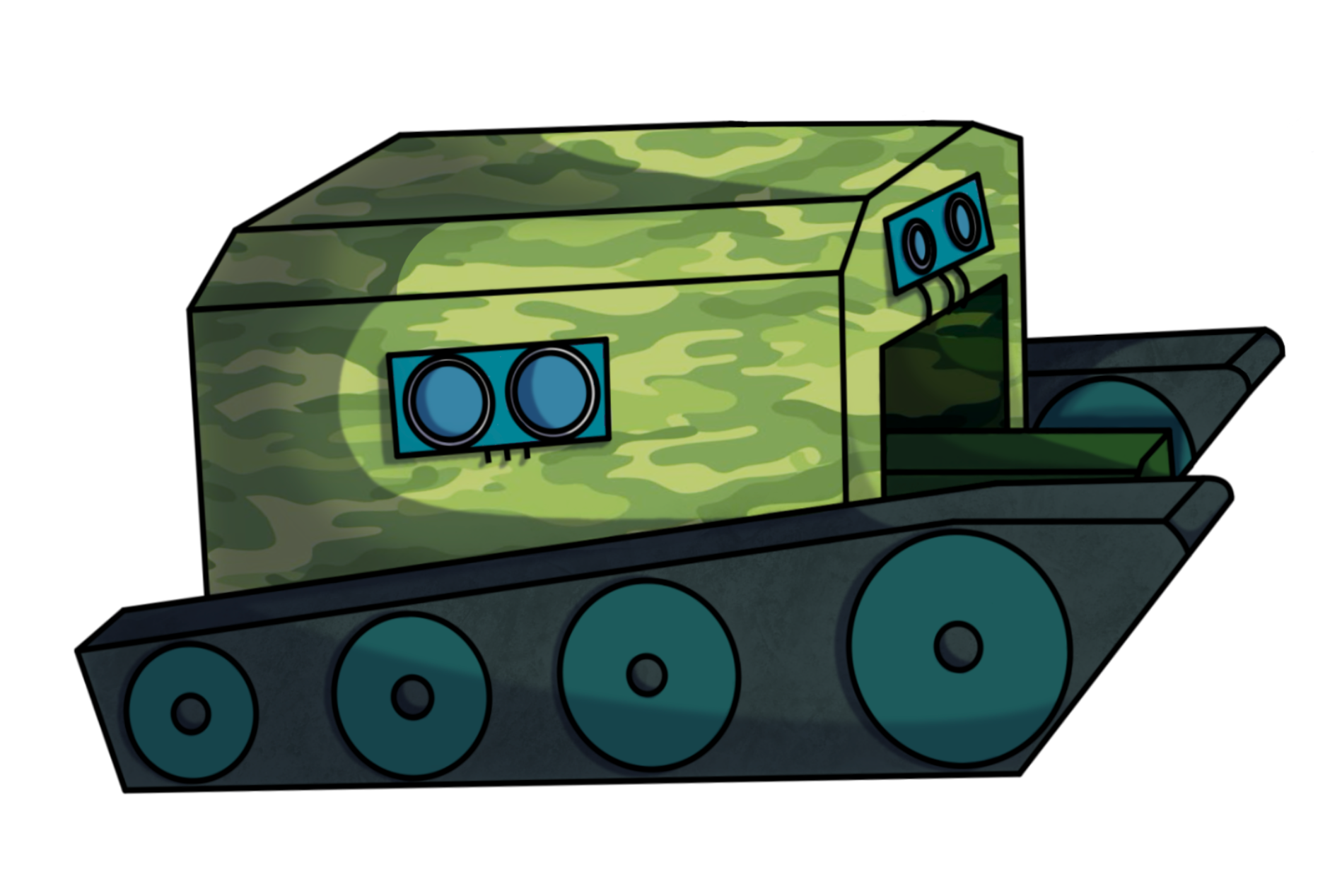The following section provides an in-depth discussion of the final design, accompanied by detailed sketches, diagrams, and cost considerations.

**Figure 1: Rescue Robot Design (Coloured) – Designed and Sketched on Procreate by Aryaman Sakthivel**

**Design Concepts:**

The design concept for the rescue robot revolves around the efficient retrieval of the tennis ball within a maze whilst avoiding collisions. The critical feature in our approach involves a lifting mechanism which is used to pick up and store the tennis ball to safely transport it back to the starting point. Our design also features several proximity sensors used to ensure the rescue robot does not collide with the maze walls.

**Lift Mechanism:**

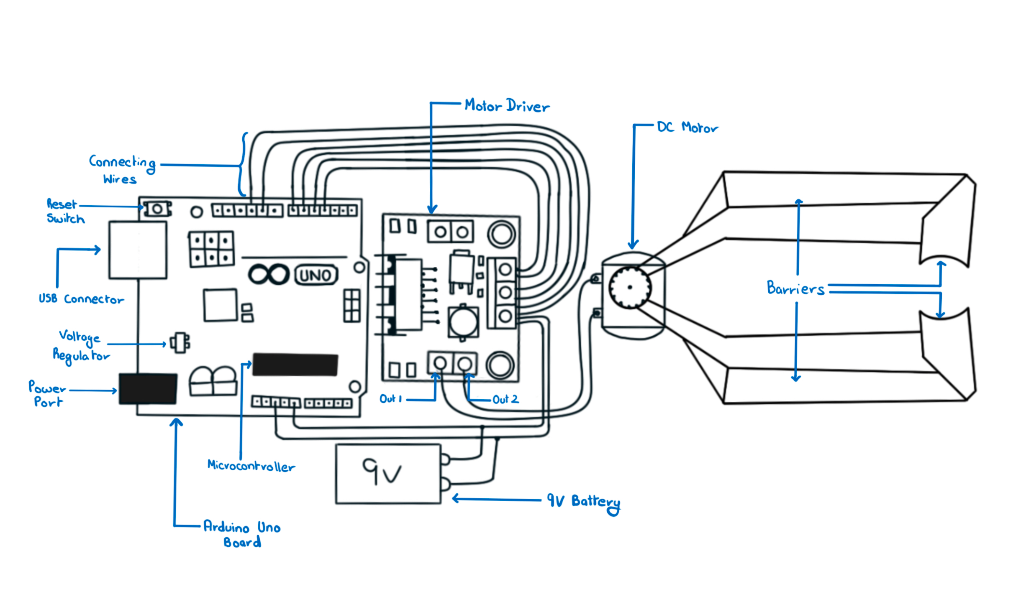Our chosen lift mechanism consists of two movable platforms with barriers in the front and on the outer side to prevent the ball from falling off while collecting as well as transporting. The apparatus will be controlled via a motor connected to the Arduino microcontroller, enabling precise retrieval with gentle ball handling. This mechanism will be integrated on to the robot’s chassis.

**Figure 2: Lift Mechanism Diagram designed and sketched by Aryaman Sakthivel**

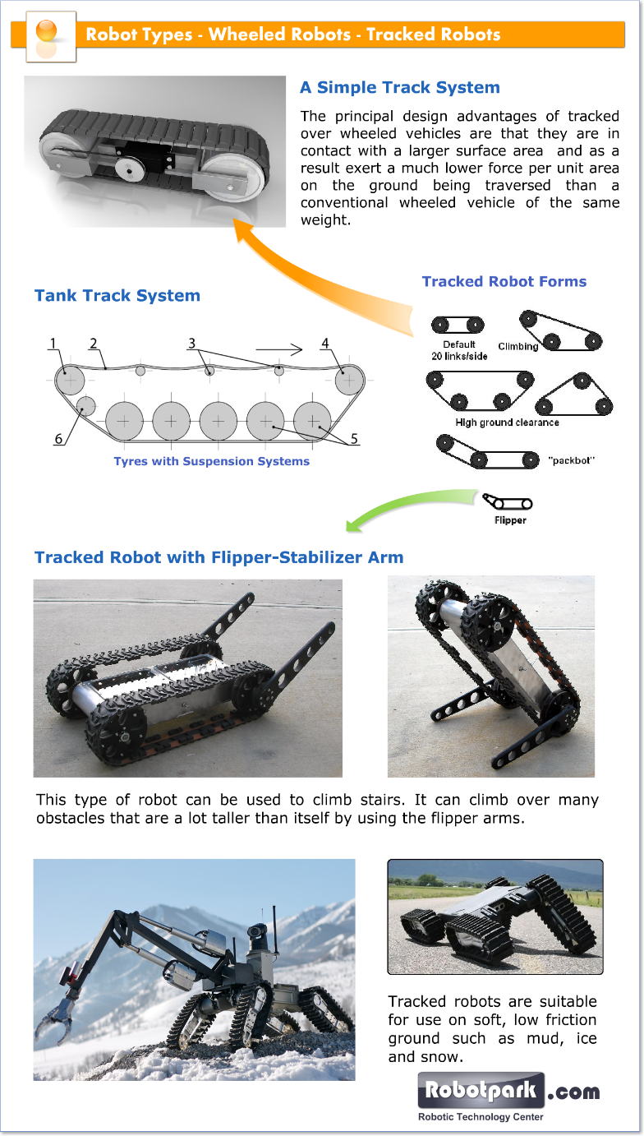**Mobility and Navigation:**

The robot’s mobility and navigation are essential considerations. In order to traverse the rough terrains and execute sharp turns within limited distances, we have opted for a “dual drive” system. We drew inspiration from the Tank steering system and opted to incorporate the 'continuous track' vehicle structure into our rescue robot.

**Dual Drive:** The dual drive system maintains power to both tracks during steering and can be used to change the speed of each track individually, thereby producing a wide range of turning circles. It even allows one track to move in reverse while the other moves forward, enabling the rescue robot to turn in place.

(Information cited from: The Evolution of a Tank Transmission by H.E. Merritt, M.B.E., D.Sc. (Eng.), M.I.Mech.E)

**Continuous Track:** The rescue robot runs on a continuous band of treads or track plates driven by two or more wheels. The principal design advantage of tracked vehicles is that they exert a much lower force per unit of area on the ground which makes them suitable for use on soft, low friction and uneven ground. Combined with wedged shaped wheels, the robot will be able to traverse up and down the stairs with ease.

(Information cited from: <https://www.robotpark.com/academy/all-types-of-robots/wheeled-robots/tracked-robots/>)

**Image 1: Robot Types – Wheeled Robots – Tracked Robots (Robopark.com)**

**Power Source:**

To power the robot’s various components, including the lift mechanism, multiple sensors, and motors, we have selected a 9V battery. This power source offers a balance between the energy capacity and weight, allowing for extended operation within the maze. The Arduino uno microprocessor can operate satisfactorily on power that is available from the USB port. It provides 5V DC voltage and can be sourced from the port from a laptop.

(Information cited from: <https://support.arduino.cc/hc/en-us/articles/360018922259-What-power-supply-can-I-use-with-my-Arduino-board-> )

**Sensing and Control:**

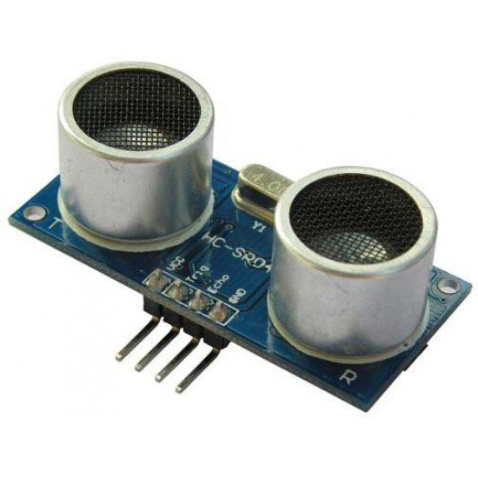

**Image 2: Ultrasonic Sensor (from CREATE NSW Inc.)**

To enhance the robot's functionality, we have integrated a combination of three ultrasonic sensors (one on each side of the robot and one in the front). These sensors provide real-time data to the robot’s control system, enabling it to navigate the maze and avoid obstacles effectively. The control system is based on an Arduino Uno microcontroller, which offers the required processing power and adaptability for the project.

We have decided to opt for the Ultrasonic Range Finder for our rescue robot project. This sensor detects the distance of the closest object in front of it (from 3 cm up to 400cm). It works by sending out a burst of ultrasound and listening for the echo when it bounces off an object. It pings the obstacles with ultrasound. The Arduino board sends a short pulse to trigger the detection, then listens for a pulse on the same pin using the pulseIn() function. The duration of this second pulse is equal to the time taken by the ultrasound to travel to the object and back to the sensor. Using the speed of sound, this time can be converted to distance.

(Information cited from: <https://docs.arduino.cc/built-in-examples/sensors/Ping> )

**Design Innovation:**

Our rescue robot project embraces a design innovation that elevates the capabilities and applications of rescue robotics. The core design concept revolves around the efficient retrieval of tennis balls within a maze, but our approach goes beyond this primary objective, introducing groundbreaking innovations:

**Lifting Mechanism Advancement:** The decision to integrate a lifting arm mechanism, providing adaptability and precision, represents a significant innovation. This mechanism ensures reliable and secure tennis ball retrieval while accommodating variations in ball (victim) size and weight. It also provides safe transportation of the ball back to the starting area.

**Tank Steering Inspiration:** The tank steering (dual drive) system as well as the ‘continuous track’ structure offers exceptional mobility and terrain adaptability. This innovation enhances the stability, manoeuvrability, and load-bearing capacity, al while minimizing environmental impact and maintenance requirements.

**Multi-Purpose Adaptability:** While our primary task is tennis ball retrieval, the design innovations we've introduced make our rescue robot adaptable to a wide range of applications. Its lifting mechanism, mobility, and sensor integration (on a larger scale) can find utility in diverse scenarios, from search and rescue operations to environmental monitoring.

**Camera System Removal:** Extensive analysis revealed that the camera system, while valuable in certain applications, is not a necessary feature for the core task of retrieving tennis balls within the maze. This is primarily because the operator will have constant visibility of both the maze and the rescue robot throughout the extraction process.

By removing this component, we effectively streamline the robot’s design and can focus on strengthening its other aspects. This decision ensures that resources are allocated efficiently and contributes to cost reduction without compromising the primary function of the rescue robot.

**Technology Integration:** The use of an Arduino Uno microcontroller enhances control and adaptability. It allows for seamless integration with sensors as well as precise control over the motors which are responsible for the lifting mechanism and the mobility, exemplifying our commitment to innovation technology integration.

**Resource Efficiency and Cost-Effectiveness:** The integration of these innovations aligns with our project’s goals. By optimizing our design and maximizing efficiency, we ensure that the robot excels in its primary mission while remaining cost effective. Although these innovations are individually significant, collectively they contribute to a well-balanced and innovative rescue robot.

**Final Design Sketch:**

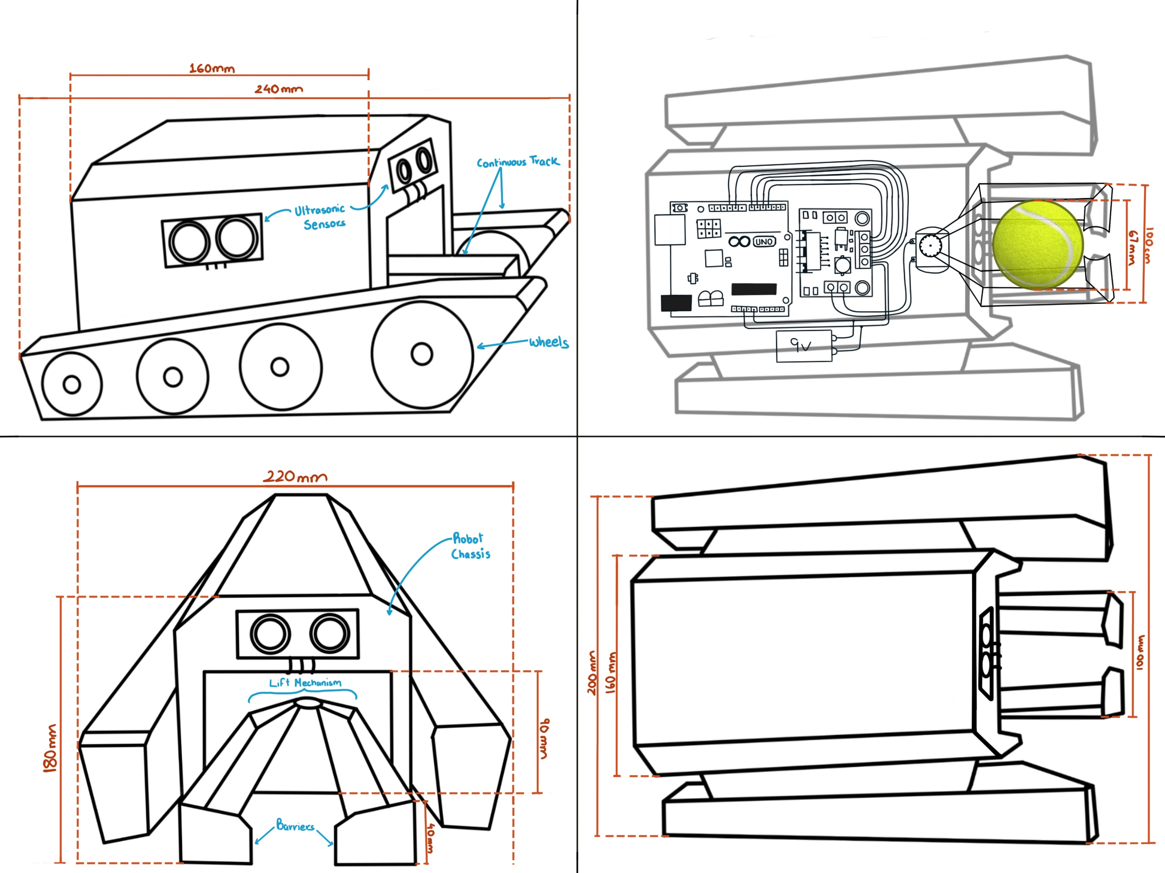

**Side View**

**X-Ray View**

**Front View**

**Top View**

**Figure 3: Final Design – by Aryaman Sakthivel**

**Budget:**

The project budget has been meticulously considered to ensure that financial resources are allocated efficiently. The detailed budget overview in Table 1 outlines the estimated costs, allowing for effective resource planning.

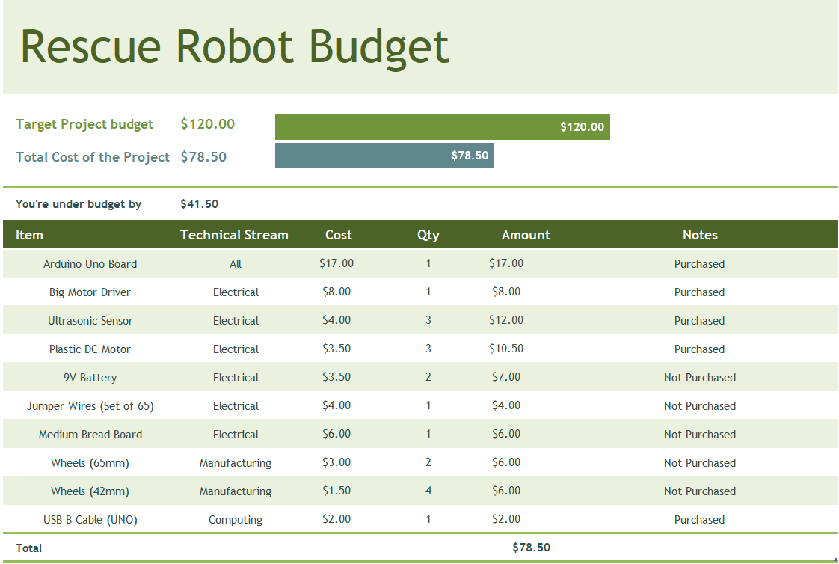**Table 1: Rescue Robot Budget Table – Team 6**

Effective budget management is a crucial component of our rescue robot project, especially with a limited budget $120 for the entire project it is necessary that the project remains financially viable. Here, we delve deeper into the key aspects of our budget management strategy:

**Cost Estimation:** The budget process begins with a comprehensive cost estimation, which considers all expenses associated with the project. This includes the procurement of materials, components, sensors, the Arduino microcontroller, power source, and the manufacturing process. Detailed cost estimates for each component are developed to create a comprehensive overview of project expenses.

**Resource Allocation:** We carefully allocate resources based on the project's requirements. Resources are allocated according to the importance of each component in achieving the project's objectives. This ensures that critical components receive the necessary funding to ensure optimal performance. The Pie chart 1 shows the allocation for each of the technical streams.

**Pie Chart 1: Budget Allocation for Technical Streams**

**Contingency Planning:** Our budget strategy includes provisions for unforeseen expenses. A contingency fund is established to address unexpected challenges or component failures. This ensures that the project remains on schedule and on budget, even in the face of unexpected issues.

**Prioritization of Key Components:** Within our budget strategy, we prioritize the allocation of the budget to the core components that directly impact the rescue robot’s primary function. This includes the motor driver, the ultrasonic sensors and the Arduino microcontroller.

**Streamlining Resources**: While prioritizing essential components, we also aim to minimize resource allocation to non-essential elements. The removal of the camera system, for instance, represents a conscious choice to optimize budget allocation. This strategic decision contributes to cost reduction while maintaining the project's core functionality.

In summary, our budget management approach is a critical aspect of our project, providing financial oversight, resource allocation, and cost-efficiency. Through prudent planning and continuous monitoring, we ensure that the rescue robot project remains on target, within budget, and capable of delivering an effective and cost-effective solution for retrieving a tennis ball within a maze.

**Conclusion:**

This design proposal encompasses the culmination of our efforts, resulting in a final design that addresses the project's goals and requirements. The lift mechanism, mobility system, power source, sensors, and control components have been carefully chosen to ensure the rescue robot's success. This design proposal will serve as a blueprint for the robot's construction and subsequent testing phase

# Project Planning – Timeline

**Tasks Details**

Task 1, 7, 12

With all engineering projects the first step is to gather requirements, including client and technical requirement. This ensures that there is no miscommunication between engineers and the clients, as well as ensuring different teams within the same project conducted thorough analysis as to whether their ideas would conflict with others.

Task 2

The second step for the manufacturing team is to begin designing the robot. This includes rough sketches and detailed schematics using CAD software – SolidWorks. The actual printing and laser cutting is only possible after this task has been completed. This is the most crucial task for the manufacturing team, as any errors occurred in this task will be reflected by the 3D printing and laser cutting.

Task 3,4

The manufacturing team will use both 3D printing and laser cutting technologies to construct the robot skeleton. The robot skeleton in this case refers to any component that is not purchased (e.g. wheels, motors etc.)

Task 5

The manufacturing team can begin building and assembly of the 3D printed and laser cutting part almost in synchronous with the 3D printing and laser cutting task, as components will be printed and cut individually, thus enabling simultaneous printing/cutting and assembly.

Task 8

For the computing team, drafting the pseudo code is the first step before programming. The pseudo code will serve as a base outline for the eventual code base. The computing team will write function skeletons and determine general logic for each function and file.

Task 9

Utilizing the concept of test-driven development, the computing team will construct unit tests before any logic is programmed. This will improve the maintainability, extendibility and recyclability of the code base.

Task 10

The computing team will commence programming robot functionality after completing unit tests.

Task 13

The electrical team will plan the general layout of the electronics by constructing circuit schematics, this will provide references and guidelines during the electrical team’s building phase.

Task 14

The electrical team will commence assembling the circuit after the circuit schematics is finalized.

Task 16

All teams will begin assembling the robot after the individual team’s tasks are close to completion. For each team, assembling can begin as soon as a single component is completed and does not need to wait for all components to be ready. This pipelined process greatly improves efficiency.

Task 17

All teams will conduct integration testing during and after the assembling phase. This ensures all team’s component are compatible and can achieve the desired functionality. This could involve testing whether the tennis ball can be properly retrieved, requiring all teams’ components to work in sync.

**Risk Assessment**

|  |  |  |  |  |  |
| --- | --- | --- | --- | --- | --- |
| **Risk** | **Description** | **RISK IMPACT**  **1 – Negligible**  **5 – Catastrophic** | **LIKELIHOOD**  **1 – Unlikely**  **5 – Likely** | **RESPONSE** | **PREVENTION AND CONTINGENCY PLAN** |
| Member on Sick Leave | Members of the team fell sick due. In particular the electrical team only has one member. | 4 | 3 | Team leader conduct inquiry and determine the duration of illness. Team leader designate temporary replacement for the sick member. | Frequent knowledge sharing among manufacturing, computing and electrical team to ensure all members are familiar with the work of other teams. If the sole electrical team member is absent due to illness, one member from the manufacturing team will be reassigned to electrical team temporary. |
| Unavailable 3D Printing Service | The 3D printing service employed in this project may be unavailable due to excess demand and/or technical difficulties. | 3 | 3 | Manufacturing team to determine the size of remaining work, i.e., how many components are in queue to be printed. | The manufacturing team will design components in such a way that it could be constructed by both 3D printing and laser cutting methods. The team will utilise laser cutting methods in the event where the 3D printing service became unavailable. |

# Risk Assessment

|  |  |  |  |  |  |
| --- | --- | --- | --- | --- | --- |
| **Risk** | **Description** | **RISK IMPACT**  **1 – Negligible**  **5 – Catastrophic** | **LIKELIHOOD**  **1 – Unlikely**  **5 – Likely** | **RESPONSE** | **PREVENTION AND CONTINGENCY PLAN** |
| Budget Overrun | Project encounters financial difficulties due to excess spending, e.g. replacing broken component due to careless handling of equipment or defective equipment | 4 | 2 | Respective team to provide new budget estimate and evaluate cheaper alternatives. | Project budget will include a safety net of 30% ($40), therefore the effective budget limit is $80. Cost overruns will be solved by the $40 safety pool. |
| Damaged Component During Rescue Operation | Component could be damaged due to wear and tear, and/or careless handling (e.g. applied excessive voltage to electrical component) | 5 | 3 | Respective team will identify and replace the damaged component within a reasonable time. | All members to document service procedure and identify components most likely to fail. Spare components to be procured before the rescue operation to minimise TTR (time to resolution) |

# References

All references must be cited in a meaningful way in the report, otherwise they are only window dressing. For example, the team might use a Pair-wise Comparison to evaluate design concepts and cite the appropriate section in the textbook.

*Plastic Geared DC Motor* n.d., store.createunsw.com.au, viewed 23 October 2023, <https://store.createunsw.com.au/components-electromechanical/motors/plastic-geared-dc-motor>.

Muro, T 1997, ‘Comparison of the traffic performance of a two-axle four wheel drive (4WD), rear wheel drive (RWD), and front wheel drive (FWD) vehicle on loose sandy sloped terrain’, *Journal of Terramechanics*, vol. 34, no. 1, pp. 37–55.

Vignati, Michele, et al. “A Torque Vectoring Control for Enhancing Vehicle Performance in Drifting.” Electronics, vol. 7, no. 12, 5 Dec. 2018, p. 394, https://doi.org/10.3390/electronics7120394. Accessed 3 July 2022.

Ultrasonic Sensor n.d., store.createunsw.com.au, viewed 23 October 2023, <https://store.createunsw.com.au/ultrasonic-sensor?search=ul%20sensor>.

Arduino Uno (Compatible) n.d., store.createunsw.com.au, viewed 24 October 2023, <https://store.createunsw.com.au/arduino-uno-compatible?search=arduino%20uno%20>.

Ping Ultrasonic Range Finder | Arduino Documentation n.d., docs.arduino.cc.

*Rescue Maze Resources* n.d., RoboCup Australia - Robotics Competition, viewed 24 October 2023, <https://www.robocupjunior.org.au/resources/rescue-maze-resources/>.

Merritt, H.E. (1946b). The Evolution of a Tank Transmission. *Proceedings - Institution of Mechanical Engineers*, 154(1), pp.412–428. doi:https://doi.org/10.1243/pime_proc_1946_154_052_02.

Robotpark ACADEMY. (n.d.). *TRACKED Robots*. [online] Available at: <https://www.robotpark.com/academy/all-types-of-robots/wheeled-robots/tracked-robots/>.

docs.arduino.cc. (n.d.). Ping Ultrasonic Range Finder | Arduino Documentation. [online] Available at: <https://docs.arduino.cc/built-in-examples/sensors/Ping>.

Arduino Support. (2022). What power supply can I use with my Arduino board? [online] Available at: https://support.arduino.cc/hc/en-us/articles/360018922259-What-power-supply-can-I-use-with-my-

# Appendices

The appendix is for supporting material that is mentioned briefly in the report, but not discussed in detail. For example, a $price for a component might appear the budget in the main report with a note pointing to the supplier’s details in ‘Appendix A’